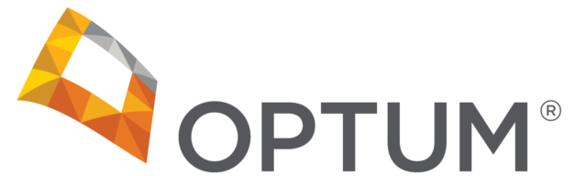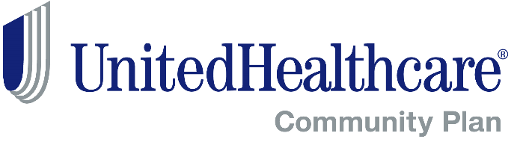

Attention: Ohio CMHC and AOD Agencies
Important Notification Regarding Medicaid Registration and Affiliation

Be prepared so that you can avoid claims payment issues for the Medicaid carve-in to Medicaid Managed Care Plans on July 1, 2018. Register and affiliate your employees immediately. Per the checklist for provider agencies as posted on the Ohio Department of Medicaid’s Behavioral Health Redesign webpage*:

“Make sure all of your employees who are covered under the rendering provider requirements outlined in the 4/19/16 edition of the MITS BITS provider newsletter are registered with Ohio Medicaid and they are affiliated with your agency. Refer to these step-by-step provider enrollment instructions. If you have any questions regarding enrollment, please email the Behavioral Health Enrollment mailbox at bh-enroll@medicaid.ohio.gov for assistance.”

Providers may contact the Provider Customer Service Center at UnitedHealthcare Community Plan of Ohio at 800-600-9007 with any questions or concerns about this message.
You may also contact Optum Network Management via email at OhioNetworkManagement@Optum.com.
Additional alerts and information can be found by going to
https://www.providerexpress.com/
- U.S. > Our Network > Welcome to the Network > Ohio
- See Ohio Medicaid and MyCare Specific News > Announcements

*Source: http://bh.medicaid.ohio.gov/Provider#52337-what-do-i-need-to-do
BH1330-032018

